SEC162: Generative AI
PROJECT TITLE:
ClassiNews: Intelligent News Article Categorization System

Submitted by
J.Lakshmi Manasa-AP23110010570
P.Thrailokya-AP23110010674
T.Abhigna-AP23110010310



BACHELOR OF TECHNOLOGY in
COMPUTER SCIENCE AND ENGINEERING
SCHOOL OF ENGINEERING AND SCIENCES
SRM University-AP, Neerukonda, Andhra Pradesh 52224
December 202
Project Description:

ClassiNews is a machine learning based system that automatically classifies news articles into categories like Politics, Sports, Entertainment, Technology, and Business. It uses Natural Language Processing (NLP) and the TF-IDF technique to convert text into numerical form, and a Multinomial Naive Bayes model to predict the news category. This project helps save time and effort by providing fast and automatic news classification for students, researchers, and media platforms.

Project Scenarios:

Scenario 1: News Website Article Classification
A news organization publishes hundreds of articles every day across different categories like politics, sports, entertainment, technology, and business. The ClassiNews system automatically analyzes each news article and instantly assigns it to the correct category, reducing manual work and saving time for editors.

Scenario 2: Student Research and Study Use
Students searching for topic-specific news for projects or research can enter any news article into the ClassiNews system. The system quickly classifies the article and helps students easily organize and understand content based on different domains.

Scenario 3: Media Monitoring and Trend Analysis
Media companies and digital marketing teams use the ClassiNews system to monitor large volumes of online news. The system continuously categorizes incoming news articles, helping organizations track which type of news is trending the most in real time.
Technical Diagram: 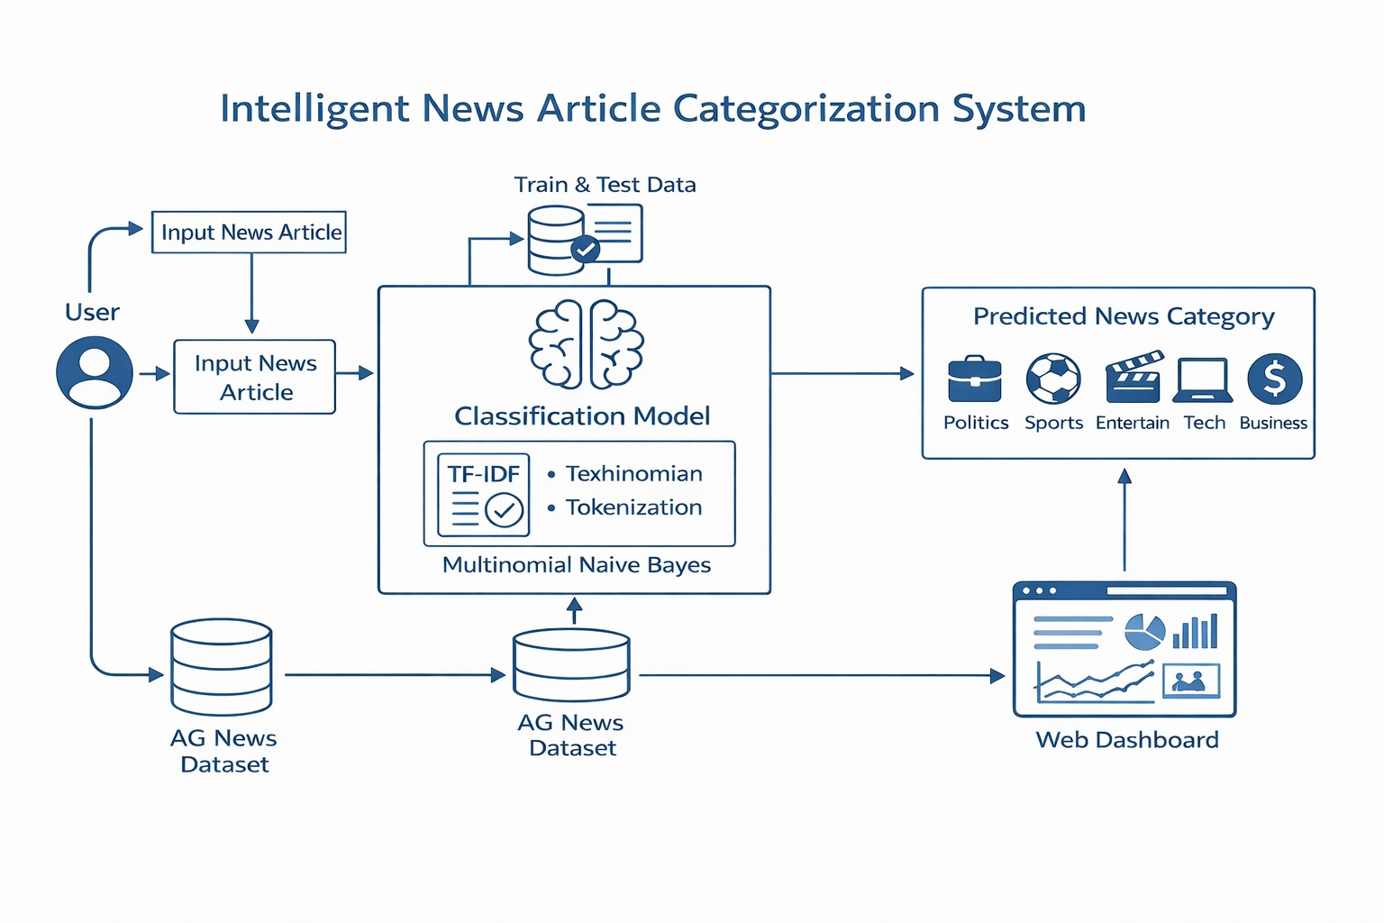

Prerequisites
To complete the ClassiNews project, the following software, tools, and packages are required.

Software Requirements
- Google Colab
- Visual Studio Code Visual Studio Code
Python Packages Required
pip install numpy
pip install pandas
pip install scikit-learn
pip install nltk
pip install matplotlib
pip install seaborn
Prior Knowledge
Before working on this project, you should have basic understanding of:
Machine Learning Concepts
● Supervised Learning (classification)
https://www.javatpoint.com/supervised-machine-learning
● Text Preprocessing & NLP basics
Tokenization, stopwords, TF-IDF.
● TF-IDF Vectorization
https://scikit-learn.org/stable/modules/generated/sklearn.feature_extraction.text.TfidfVectorizer.html
● Logistic Regression (Classical ML Model)
https://www.javatpoint.com/logistic-regression-in-machine-learning
● Evaluation Metrics
Accuracy, Precision, Recall, F1-score
https://www.analyticsvidhya.com/blog/2019/08/11-important-model-evaluation-error-metrics/
● Transformer Models (BERT)
https://huggingface.co/docs/transformers/index
● Flask Basics: https://www.youtube.com/watch?v=lj4I_CvBnt0
Project Flow:
● User enters a news article as input through the system
● The system preprocesses the input text by converting it into lowercase and cleaning it
● The cleaned text is converted into numerical form using the TF-IDF Vectorizer
● The trained Multinomial Naive Bayes machine learning model analyzes the extracted features
● The predicted news category (Politics, Sports, Entertainment, Technology, or Business) is displayed along with probability scores

Project Activities

1. Data Collection & Preparation
● Collected the news dataset
● Cleaned and prepared the text data

2. Exploratory Data Analysis
● Checked category distribution
● Viewed sample news articles

3. Model Building
● Applied TF-IDF for feature extraction
● Trained the model using Naive Bayes

4. Performance Testing
● Tested the model on test data
● Measured accuracy and confusion matrix

5. Deployment
● Built a console-based prediction system
● Implemented real-time news classification
Project Structure:
Create the Project folder which contains files as shown below
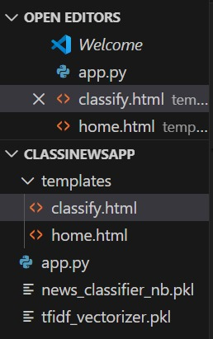
Project Structure Explanation:
● CLASSINEWSAPP/
Main project folder that contains all application files.
● templates/
Contains the HTML files used for the Flask web interface.
○ home.html – Home page where the user enters the news article.
○ classify.html – Result page where the predicted category is displayed.
● app.py
Main Flask backend file that loads the trained model and TF-IDF vectorizer, handles user input, performs prediction, and displays the result.
● news_classifier_nb.pkl
Trained Multinomial Naive Bayes machine learning model saved for future use.
● tfidf_vectorizer.pkl
Saved TF-IDF Vectorizer used to convert input text into numerical features

Milestone 1: Data Collection & Preparation
In the ClassiNews project, the news dataset was collected in CSV format with news articles and their categories. The data was checked and cleaned by converting all text into lowercase and preparing it for feature extraction. This step helped improve the performance of the machine learning model.

Activity 1.1: Collect the Dataset
There are many ways to collect text data such as online news sites, APIs, surveys, and cloud-based documents. In this project, the dataset was collected using a Google Drive document, where the news articles and their categories were manually prepared and stored. The dataset was then downloaded in CSV format and uploaded into Google Colab for further processing.
Link: https://drive.google.com/file/d/1s94_vbibhxpMZ7Wx7o0PbNFrbBlFZkU/view?usp=sharing
After uploading the dataset, it was read and analyzed using basic viewing techniques to understand the structure, columns, and category distribution. Simple analysis methods were used to explore the dataset, though many other techniques can also be applied if needed.

Data Source: https://drive.google.com/file/d/1s94_vbibhxpMZ7Wx7o0PbNFrbBlFZkU/view?usp=sharing
The dataset used in the ClassiNews project contains the following features:
● article – The news article text
● category – The news category (Politics, Sports, Entertainment, Technology, Business)
The dataset file is stored in CSV format and contains multiple news records collected through Google Drive

Activity 1.2: Importing the Libraries
Import the necessary libraries as shown below:

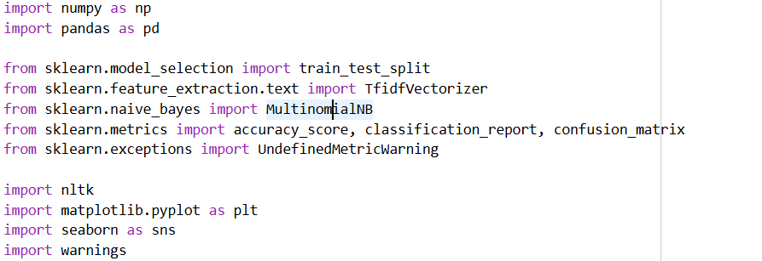
These libraries serve the following purposes:
● NumPy – For numerical operations
● Pandas – For data loading and data manipulation
● Scikit-learn – For TF-IDF, model training, and evaluation
● NLTK – For basic text preprocessing
● Matplotlib – For creating visual outputs
● Seaborn – For confusion matrix visualization
● Flask – Used to create the web application
● render_template – Used to load HTML pages
● request – Used to receive user input from the web form
● joblib – Used to load the saved machine learning model and TF-IDF vectorizer
Activity 1.3: Read the Dataset
Our dataset is in CSV format. We read the dataset using pandas:
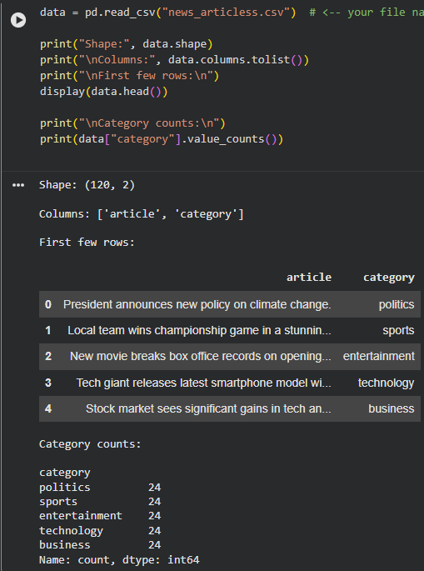
The head() function displays the first 4 rows of the dataset, giving us a quick overview of the
data structure and values.
Activity 1.4: Data Preparation
Before we can use our data to teach our machine-learning model, we need to clean it up. This
includes:
● Handling missing values
● Removing duplicates
● Checking data types
● Handling outliers
Note: These are general steps for pre-processing data. Depending on the condition of your
dataset, you may or may not have to go through all these steps.

Activity 1.5: Handling Missing Values
Step 1: Check the dataset information and null count of each column:
After loading the news dataset, the basic information of the dataset was checked to understand the total number of entries, column names, and data types. This also helped in identifying whether any missing values were present in the dataset.
Step 2: Check the size of the dataset:
The shape of the dataset was verified to understand the total number of rows and columns used for news classification.
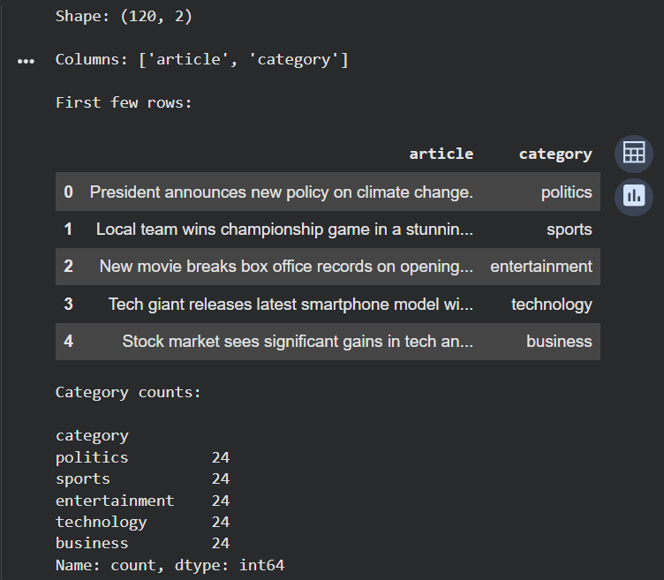
Step 3: Check for null values:
The dataset was checked for missing or null values in both the article and category columns. Fortunately, no missing values were found in the dataset. Since the data was already complete and clean, no further missing value handling was required.

Activity 1.6: Handling Duplicates
After handling missing values, the news dataset was checked for duplicate records. Duplicate news articles can affect the accuracy of the classification model by repeating the same information multiple times. The dataset was carefully examined, and since it was manually prepared and properly organized, no duplicate records were found. Therefore, no duplicate removal process was required, and the dataset was used as it is for further processing.
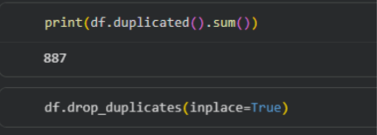

Activity 1.7: Checking for Outliers
Outliers are unusual values that can affect model performance. In the ClassiNews project, the data mainly consists of text-based features rather than numerical values.
Since this is a text classification project, traditional numerical outlier detection methods such as boxplots are not required. However, the dataset was manually reviewed to ensure that all news articles were valid and properly labeled. As a result, no abnormal or incorrect data entries were found in the dataset.

Milestone 2: Exploratory Data Analysis
Exploratory Data Analysis (EDA) is used to understand the structure, patterns, and distribution of the news dataset. It helps in identifying how the data is spread across different news categories before model training.

Activity 2.1: Descriptive Statistics
Step 1: View basic dataset information:
The dataset information was checked to understand the total number of news articles, column names, and data types.
Step 2: Check category distribution:
The count of each news category such as Politics, Sports, Entertainment, Technology, and Business was displayed. This helped in understanding how balanced the dataset is.
Step 3: Display sample records:
A few sample rows from the dataset were displayed to understand how the news articles and categories are stored.
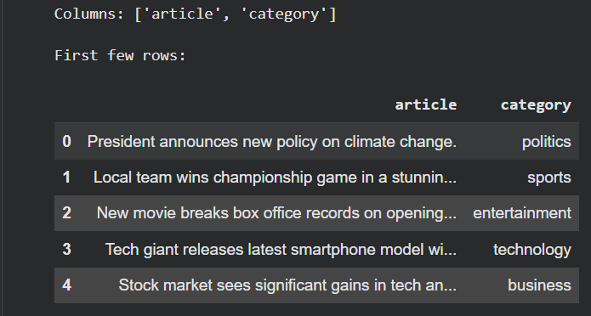

Activity 2.2: Visual Analysis
Visual analysis was used to understand the distribution of news categories clearly.
To achieve this, simple plots were generated to show how many articles belong to each category. This helped in visually verifying that the dataset is evenly distributed and suitable for training the machine learning model.
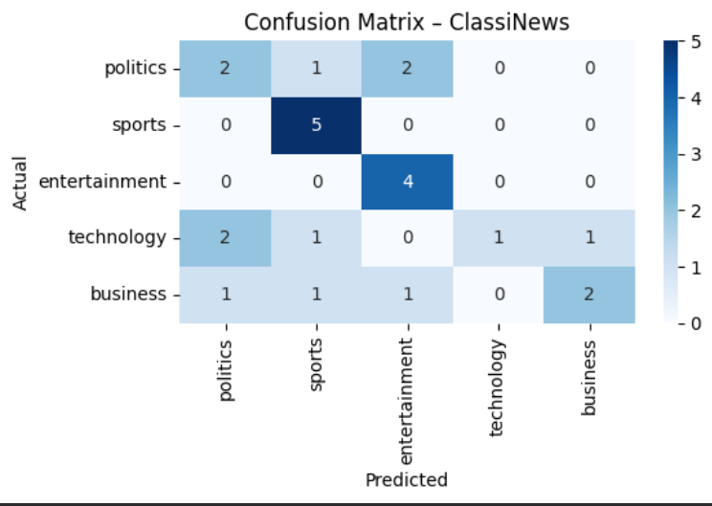

Activity 2.3: Univariate Analysis
Univariate analysis was performed by analyzing each feature individually.
In this project:
- The article column was analyzed to understand the nature of text data.
- The category column was analyzed to observe how news articles are distributed among different classes.
This helped in understanding the dataset before applying feature extraction and model training.

Activity 2.4: Bivariate Analysis
Bivariate analysis is used to study the relationship between two features.
In this project, the relationship between the news article text and its category was analyzed. This helped in understanding how different types of words and phrases appear in different news categories like politics, sports, and technology. This analysis supported the feature extraction process used later in the model.

Activity 2.5: Correlation Analysis
Correlation analysis is generally used to study relationships between numerical features. Since the ClassiNews dataset contains text-based data, traditional numerical correlation methods are not directly applicable.
However, the relationship between the input text features (after TF-IDF conversion) and the output category labels was indirectly analyzed through model performance and prediction results.

Activity 2.6: Feature Extraction Using TF-IDF
Before training the machine learning model, the news articles were converted into numerical form using the TF-IDF (Term Frequency–Inverse Document Frequency) Vectorizer.
This process assigns importance to words based on:
- How frequently a word appears in a document
- How rare the word is across all documents
The TF-IDF vectorized data was then used as input to train the Naive Bayes model.
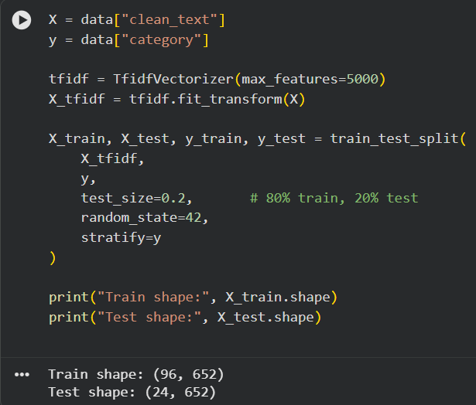

Activity 2.7: Train–Test Split
After feature extraction, the dataset was divided into two parts:
- Training set (80%) – Used to train the model
- Testing set (20%) – Used to evaluate model performance
This helped in checking how well the model works on unseen news data.
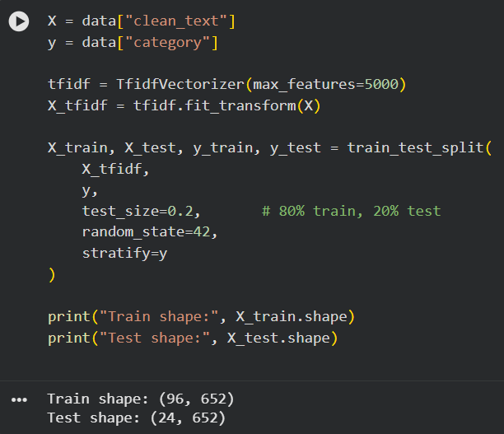

Milestone 3: Model Building
In this milestone, the actual machine learning model was built and trained using the prepared news dataset. The aim was to develop a model that can accurately classify news articles into different categories.

Activity 3.1: Import Required Libraries
The required machine learning libraries such as Scikit-learn were imported for model training, prediction, and evaluation. These libraries provide built-in functions for training classifiers and measuring their performance.
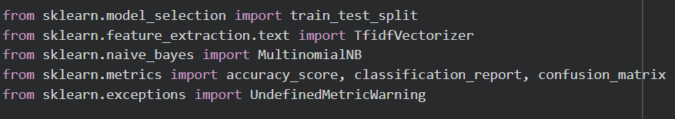

Activity 3.2: Model Training Using Multinomial Naive Bayes
The Multinomial Naive Bayes algorithm was selected for training the model as it performs well for text classification problems.
The TF-IDF converted training data was given as input to the model. The model learned the patterns between the news article text and their corresponding categories during the training process.
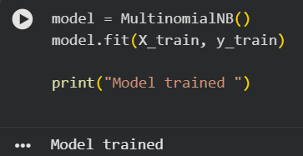

Activity 3.3: Model Prediction
After training, the trained Naive Bayes model was used to predict the categories of the test dataset. The predicted outputs were compared with the actual category labels to measure performance. 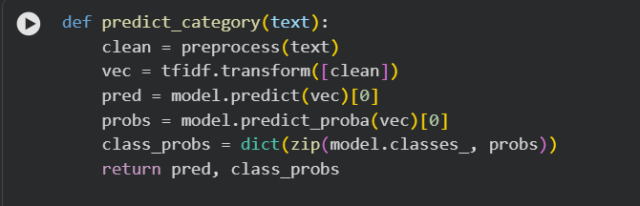

Milestone 4: Performance Testing & Model Evaluation
This milestone focuses on checking how accurately the trained model classifies new news articles.

Activity 4.1: Model Accuracy
The accuracy of the ClassiNews model was calculated using the test dataset. This value represents the percentage of correct predictions made by the model on unseen data.
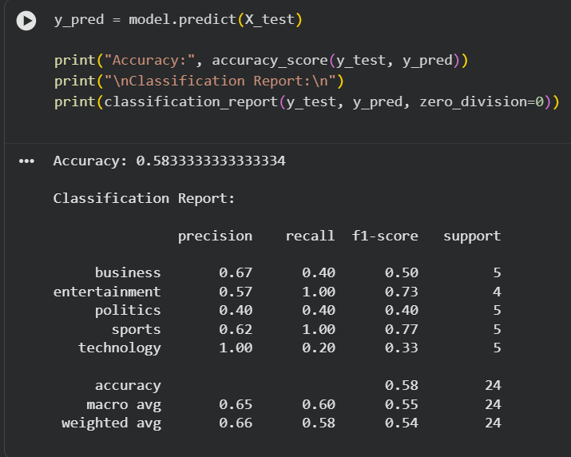

Activity 4.2: Classification Report
A classification report was generated to evaluate the model using:
- Precision
- Recall
- F1-Score
- Support
This report helped in understanding how well the model performs for each individual news category.

Activity 4.3: Confusion Matrix
A confusion matrix was created to visually represent:
- Correct predictions
- Incorrect predictions
- Misclassification between categories
The confusion matrix helped in identifying which categories the model predicts accurately and where it gets confused.
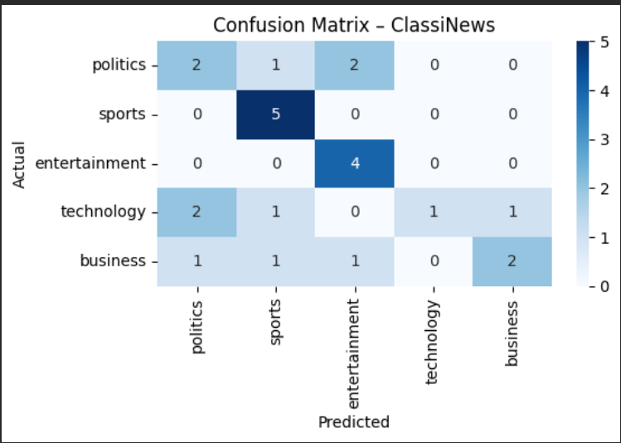

Milestone 5: Model Deployment
After training and testing the model, the final step was to deploy the ClassiNews system so that users can easily interact with it and classify news articles in real time.

Activity 5.1: Saving the Trained Model
Once the Multinomial Naive Bayes model was trained successfully, it was saved using a model file so that it can be reused for predictions without retraining the model again. The TF-IDF vectorizer was also saved for converting new input text into numerical features during deployment.
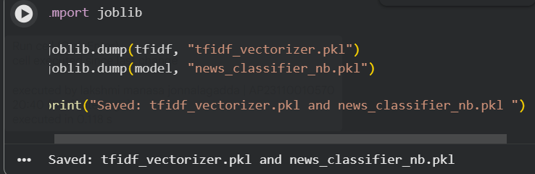

Activity 5.2: Flask Web Application Development
A Flask web application was developed to provide a simple and user-friendly interface for ClassiNews. The Flask framework connects the machine learning model with the frontend so that users can enter news articles and get predictions instantly.
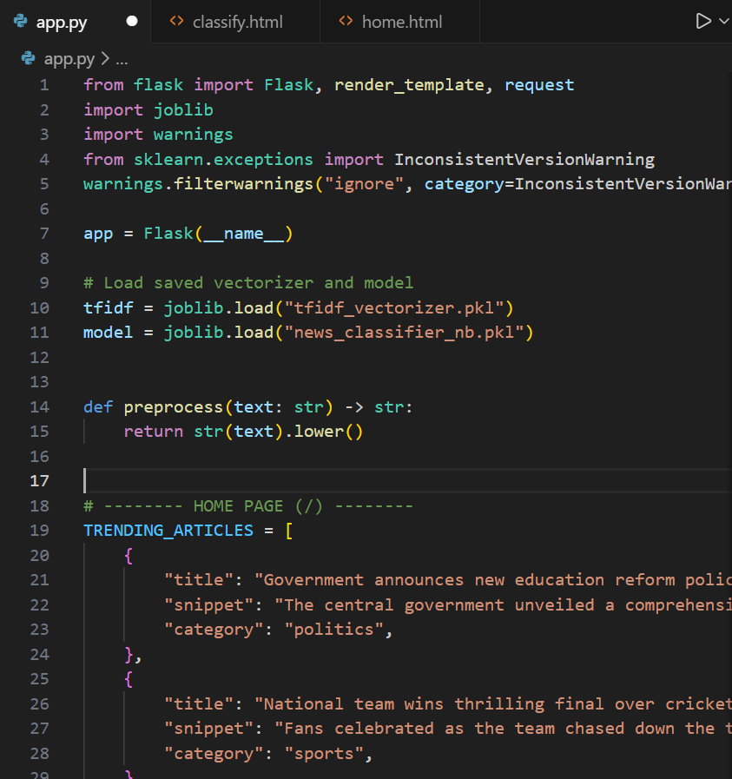

Frontend Implementation (HTML Templates)
The frontend of the ClassiNews system is designed using simple HTML files.
- home.html – This page allows the user to enter a news article.
- classify.html – This page displays the predicted news category after classification.
These pages provide an easy way for users to interact with the system.
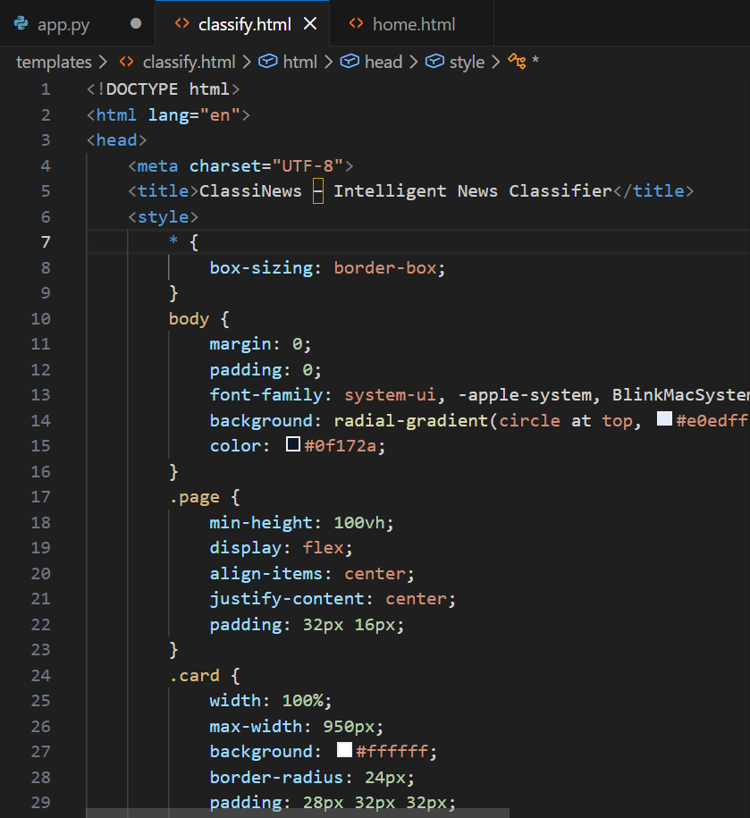
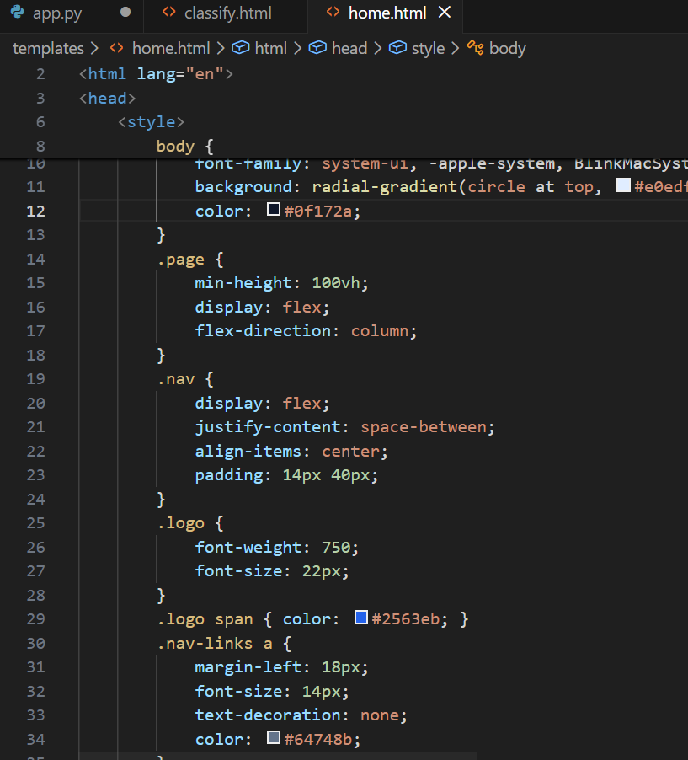

Backend Implementation (app.py)
The backend of the application is handled using Flask in the app.py file.
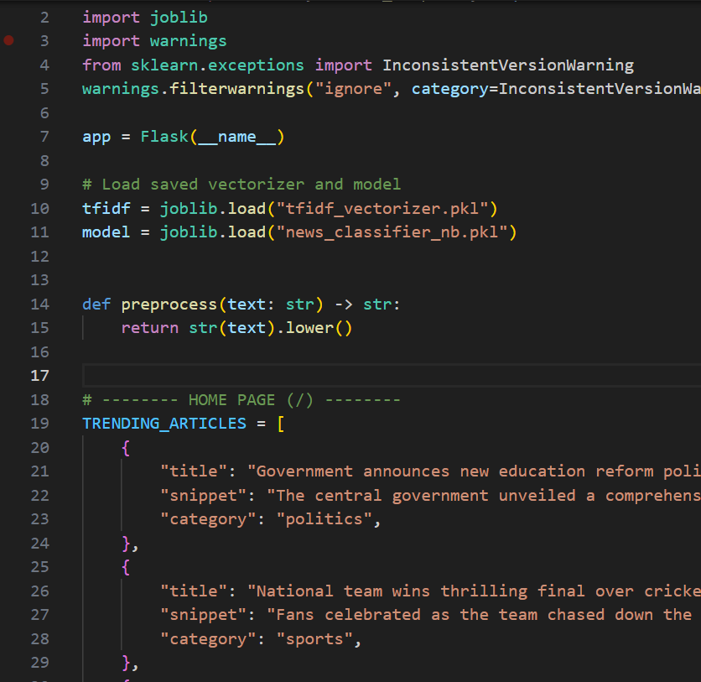
The backend performs the following tasks:
- Loads the saved Naive Bayes model
- Loads the TF-IDF vectorizer
- Receives the user’s news input
- Converts the input text into numerical form
- Predicts the news category
- Displays the final result on the webpage

Live News Prediction System
The project also supports a live prediction system where the user can enter any news article and instantly get the predicted category. The model also displays the probability of each category, helping the user understand how confident the model is about the prediction.
Application screenshorts and workflow
Frontend Overview – ClassiNews
The ClassiNews frontend provides a simple and user-friendly interface for automated news classification. On launching the application, users are presented with a clear description of the system’s purpose—classifying news articles into categories such as Politics, Sports, Entertainment, Technology, and Business using a machine learning model.
The homepage includes options to try the classifier or view trending headlines, allowing users to quickly understand the system’s functionality. Categorized news cards with headlines and brief descriptions visually demonstrate how articles are classified. The clean layout and responsive design ensure easy navigation and an effective user experience.
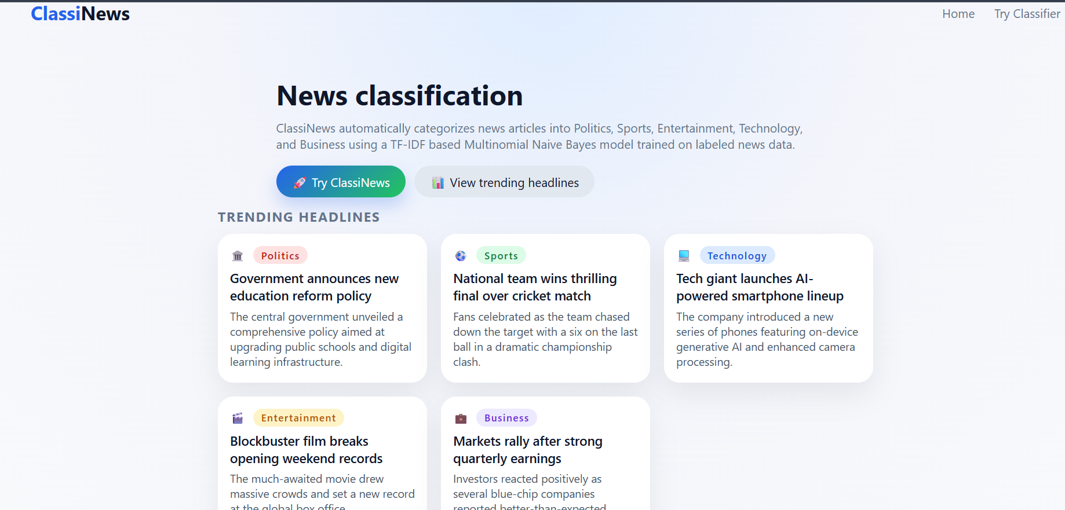
Trending Headlines Section
The Trending Headlines section displays sample news articles categorized into Politics, Sports, Technology, Entertainment, and Business. Each headline card includes a category label, a news title, and a brief description, visually demonstrating how the classification system organizes news content. This section helps users quickly understand the effectiveness of the model and provides example inputs before trying the classifier themselves.
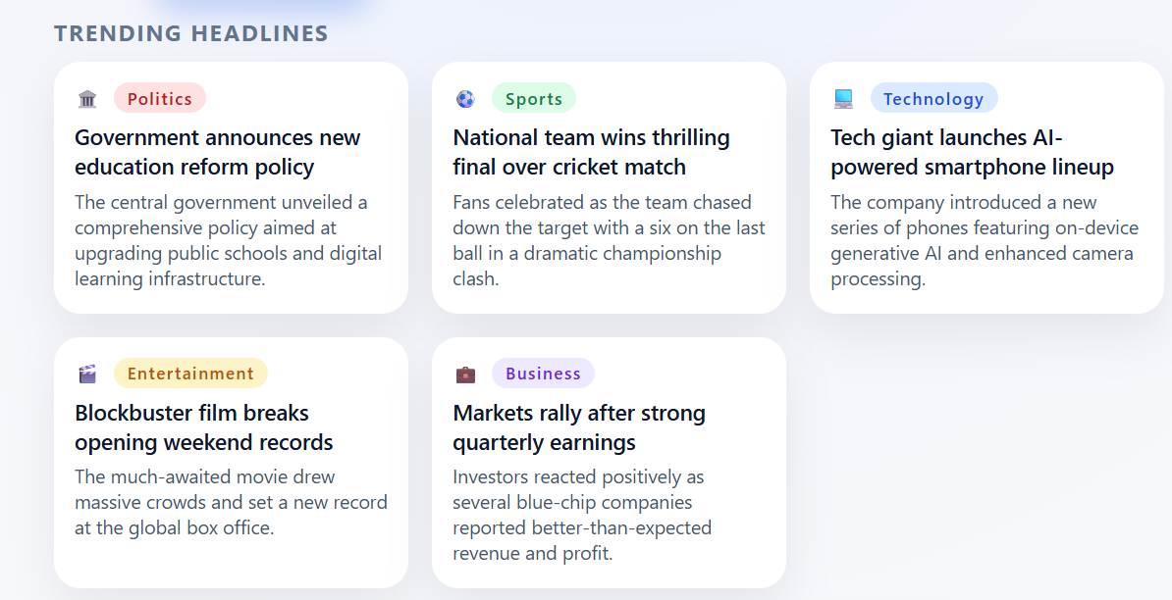
Try Classifier Section
The Try Classifier section allows users to input or paste any news article into a text area for real-time classification. Once the user submits the text, the system processes the article using TF-IDF feature extraction and a Multinomial Naive Bayes model to predict the appropriate news category. This interactive feature enables users to directly experience the functionality and accuracy of the news classification system
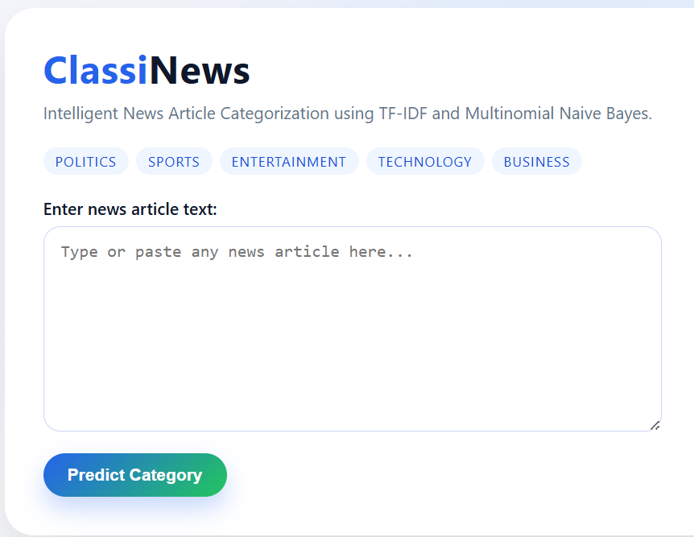
Prediction Output Section
The Prediction Output section presents the final classification result generated by the system for the given news article. Once the user submits the input text, it is processed using TF-IDF feature extraction and classified using a Multinomial Naive Bayes model. The predicted news category is displayed prominently along with a short descriptive explanation of the category. This output enables users to clearly understand the classification result and demonstrates the effectiveness of the machine learning model in categorizing news articles accurately.
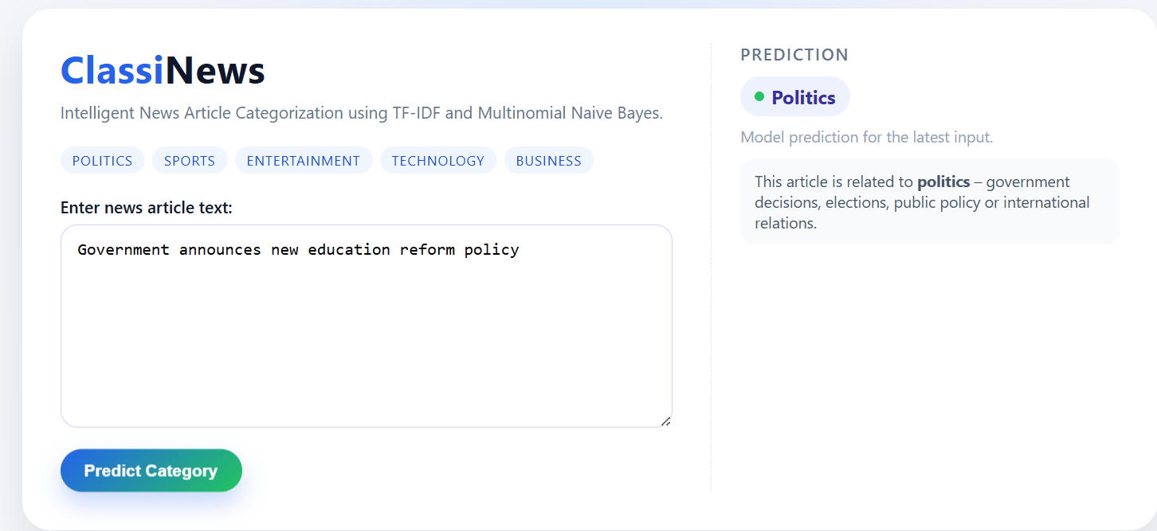

Future Scope
The ClassiNews project can be further improved by:
- Increasing the size of the dataset
- Adding more news categories
- Using deep learning models like LSTM or BERT
- Adding live news API integration
- Improving accuracy with advanced NLP techniques

Conclusion
The ClassiNews project successfully demonstrates how machine learning and Natural Language Processing can be used to automatically classify news articles into different categories. By using the TF-IDF Vectorizer and the Multinomial Naive Bayes algorithm, the system efficiently predicts the correct category for a given news article. This project provides a strong foundation for building advanced AI-based text classification systems in the future.

